Rotary Club of Kathmandu Mid-Town
Breakfast Chatter




24 February 2012 The Weekly Bulletin of Rotary Club of Kathmandu Mid-Town Bc-2.24/011-12

District: 3292 Web: www.rotarymidtown.org.np Club Id : 26776

FEBRUARY IS WORLD UNDERSTANDING MONTH
Advancing world understanding and peace, which is expressed in the fourth part of the Object of Rotary,
is an important focus of Rotarian service. It is the impetus for numerous service efforts and other cooperative ventures among Rotarians from different parts of the world. It is the reason Rotary International has a longstanding, close collaboration with the United Nations and many of its member agencies.
Appropriately, every year the anniversary of the founding of Rotary, 23 February, is celebrated as World Understanding and Peace Day..

17 February, Friday:
Dr. Suman Thapa, chief of Glaucoma Unit of Teelganga Eye Hospital, Kathmandu was our guest Speaker who spoke
on the topic “Delivering Glaucoma Care in Nepal: A New Beginning.”
Glaucoma is the term applied to a group of eye diseases that gradually result in loss of vision by permanently damaging the optic nerve, the nerve that transmits visual images to the brain. The leading cause of irreversible blindness, glaucoma often produces no symptoms until it is too late and vision loss has begun.
An elevation in the pressure within the eye (the intraocular pressure, or IOP) is generally, but not always, associated with
the development of glaucoma, although additional factors are also likely to play a role in its development. The optic nerve
fibers inside the eye are damaged, resulting in vision loss that begins in the peripheral fields of vision. Glaucoma usually
affects both eyes, but one eye may be more severely affected than the other.
Worldwide, glaucoma is the leading cause of irreversible
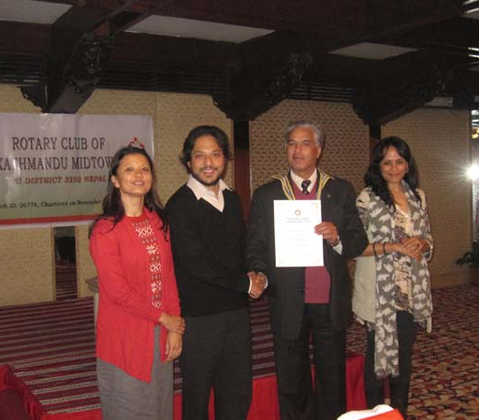
blindness. In fact, as many as 6 million individuals are blind in
both eyes from this disease. As many as half of the individuals
with glaucoma, however, may not know that they have the
disease. The reason they are unaware is that glaucoma initially
causes no symptoms, and the subsequent loss of side vision
(peripheral vision) is usually not recognized.
In the majority of cases, vision loss usually occurs when the eye
pressure is too high for the specific individual and damages the
optic nerve. Any resultant damage cannot be reversed. In eyes
with glaucoma, peripheral (side) vision is affected first. The
changes in vision may be so gradual that they are not noticed
until a lot of vision loss has already occurred.
In time, if the glaucoma is not treated, central vision will also be
decreased and then lost; this is how blindness from glaucoma is
most often noticed. The good news is that glaucoma can be
managed if detected early, and with medical and/or surgical
treatment, most people with glaucoma will not lose their sight.
President Som providing certificate of appreciation to
Guest speaker Dr Suman Thapa while Mrs Thapa and
her friend look on.

Weekly Meetings and Programs :
Date | Program/Speaker | Program/Topics of Presentation
24 February 2012 | Dr Franz Josef Radermacher | Peace and world understanding
2 March 2012 | Dr Niti Rana | The Phenomenon of school bullying
9 March 2012 | Rtr Samir Nepal | Rotaract/Rotary Collaborations: 2011/12 achievements
16 March 2012 | Mr Prashanta Singh | Himalayan Climate Initiatives: Success and Challenges

On RI 2012-013 Theme: Peace through Service:
“Peace is the ultimate purpose of every human, country, community, and family. Peace concerns everybody. This is a great theme because peace is something deep to all of us.” – DGE Tokunao Tanaka, Japan
“The idea of peace fits perfectly with Rotary. There are so many ways the theme can be interpreted, and it’s my goal to help clubs interpret in a way that suits them best.” – DGE Thomas Fallon, Pennsylvania, USA
“When people think of peace they first think of stopping war. But this theme touches on much more – hunger, education, and so many other things. The theme will resonate well.” – DGE Laura Day, California, USA
“Peace through Service gives another dimension to our motto of ‘Service above self’. It gives us more reason to serve our community and the rest of the world which is to achieve peace within ourselves, our family, our community and our only world. – Rtn Lirio Sandoval
“Let there be PEACE in our heart, PEACE in our home, PEACE in our Nations and around the World.Am so glad it is coming through Rotary International which makes it an accomplished task no matter what it takes,that I believe.” – Rtn Nwulu Nancy I
Source: Rotary International News

Rotary South Asia Conference on Literacy:
Rotary South Asia Conference on Literacy is going to be held on 1-3 March 2012 at Hotel Hyatt, Kathmandu, Nepal to discuss the state of literacy, the shortcomings and the opportunities to work towards literacy.
More than two hundred Rotarian participants from India and other south Asian nations are expected to attend this Conference. RI District 3292 is the host to one of the most prestigious Rotary programs ever held in our country, and therefore, we all should put an effort to participate in the conference in as many numbers as we can in order to make this conference a grand success.
The registration fee for Nepalese Rotarians is Rs. 6,500/- only per person which includes cocktails, two dinners and two lunches at hotel Hyatt. The registration should be completed by 25th of February and registration after that will cost Rs.7,500/-.

India prepares for Polio Summit 2012:
In the wake of India achieving one year without a case of polio, the Indian Ministry of Health and Family Welfare, in partnership with Rotary International, is organizing Polio Summit 2012. It will be held 25-26 February in New Delhi.
The summit is aimed at sustaining the country's momentum toward eradicating polio by increasing awareness of the disease, securing strong support from governments and other partners, and promoting routine immunization. The meeting also will create a platform for government and health officials to develop a strategy for ending the disease in the three other countries where it is endemic -- Afghanistan, Nigeria, and Pakistan -- and throughout the world.
More than 1,000 government leaders, health officials, and Rotarians from India and neighboring countries, along with representatives from Rotary International, the World Health Organization, UNICEF, the U.S. Centers for Disease Control and Prevention, and the Bill & Melinda Gates Foundation, are expected to attend the event.
“The Polio Summit will help greatly in continuing advocacy with political, bureaucratic, and religious, as well as corporate and social, leaders and other organizations,” says RI President Kalyan Banerjee.
Before the summit, on 19 February, more than 200 Rotarians from several countries will participate with their Indian counterparts in the country’s National Immunization Day. About half of the visiting Rotarians also plan to attend the Polio Summit.
Afterward, on 27 February, the annual National PolioPlus Orientation and Planning Meeting for RI governors-elect and district PolioPlus chairs will be held in New Delhi, hosted by the India PolioPlus Committee.
“India is tantalizingly close to eradicating polio,” says Past RI President Rajendra K. Saboo, chair of the summit. “Rotary International has committed to be the torchbearer until India and the world become polio-free.”
Ghulam Nabi Azad, India's minister of health and family welfare, credited Rotary with helping his country near the goal of polio eradication when he spoke at RI World Headquarters in Evanston, Illinois, USA, in September. He cited “not only the mobilization of funds, but the active participation of Rotarians in the field,” and said, “My country has benefited greatly from your support, and I thank all of you.”
Source: Dan Nixon/Rotary International News

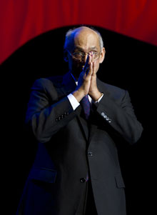

Success never depends, and never will depend, on position, or equipment, or even on
numbers. It depends on feelings — the feeling that is in me, and in him, and in each of us.
RI President Kalyan Banerjee

On Lighter Side : Click here ⇩


A thought for the day:
In order that people may be happy in their work, these three things are needed:
they must be fit for it; they must not do too much of it;
and they must have a sense of success in it.
- John Ruskin

Zero all the way:
We live in a zero-sum society. There are zeros all over in our social life. Our leaders are also talking about several zeros – zero tolerance to corruption and human rights violation, zero tolerance to insecurity, zero political interference in security agencies, zero this and zero that. And our intellectuals feel this is their time to profess zero intervention also in the state affairs regardless of whether the country is heading to a dark hole or through a dark tunnel without any streak of light.
And, mathematics says zero does not take you any further from where you stand. By its nature, it will force you to move in a circle.
Intellectuals of the country can and must play their roles to bring about the desired change in the society, and in the country. Why does this important organ of the society remain relatively calm and quiet about the current problems such as lawlessness, corruption, mismanagement and lack of accountability – pushing the country towards a more dangerous ditch from where there is no return ?
Their zero commitment is costing the nation high.
Source: Prem Khatry /The Rising Nepal

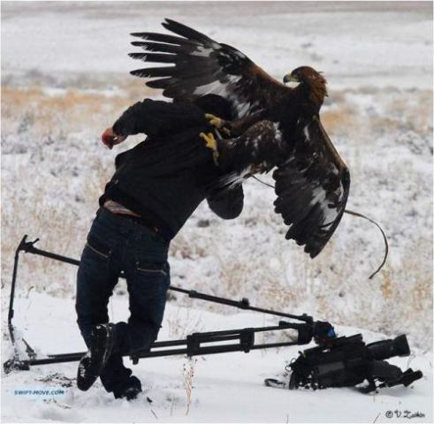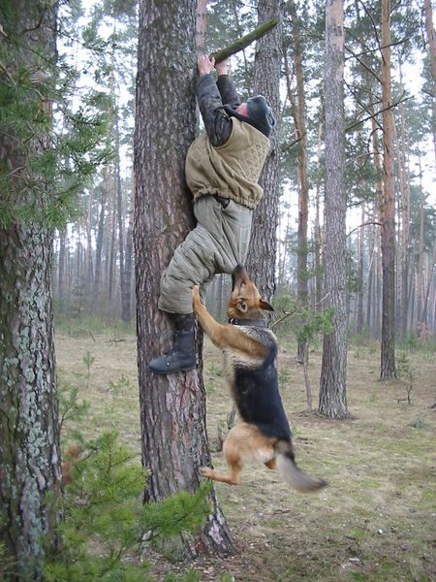
Nature and amazing photography

Please send project/activity information, suggestions and photos etc to :
BC Editor: RR Shrestha email: rryes@wlink.com.np

24 February 2012 The Weekly Bulletin of Rotary Club of Kathmandu Mid-Town bc-2.24/011-12

